Q16. Prepare report that shows the steps of installation of WordPress and Joomla CMS.

Installing WordPress

- Download and install XAMPP from apachefriends.org.
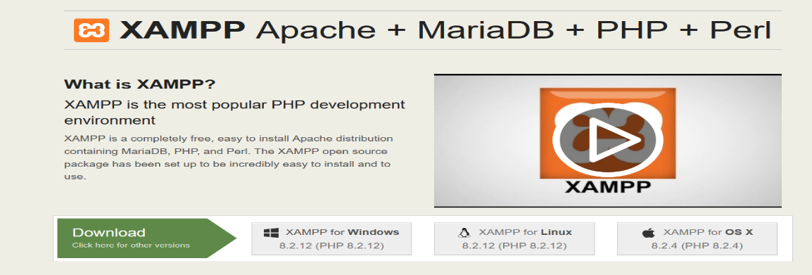

- Open XAMPP Control Panel and start Apache and MySQL.
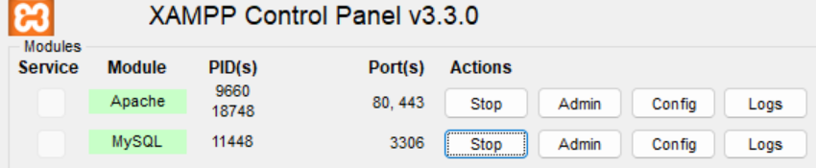

- Go to http://localhost/phpmyadmin and create a new database named wp_db.
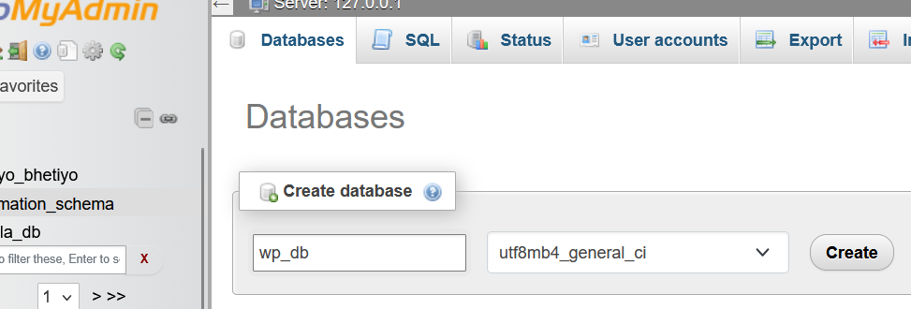

- Download WordPress from wordpress.org/download.
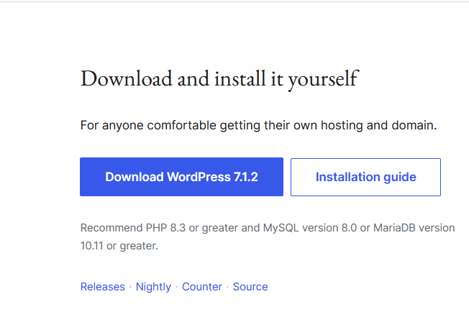

- Extract the WordPress folder into C:\xampp\htdocs\wordpress.
- Open http://localhost/wordpress in the browser, select language and click Continue.
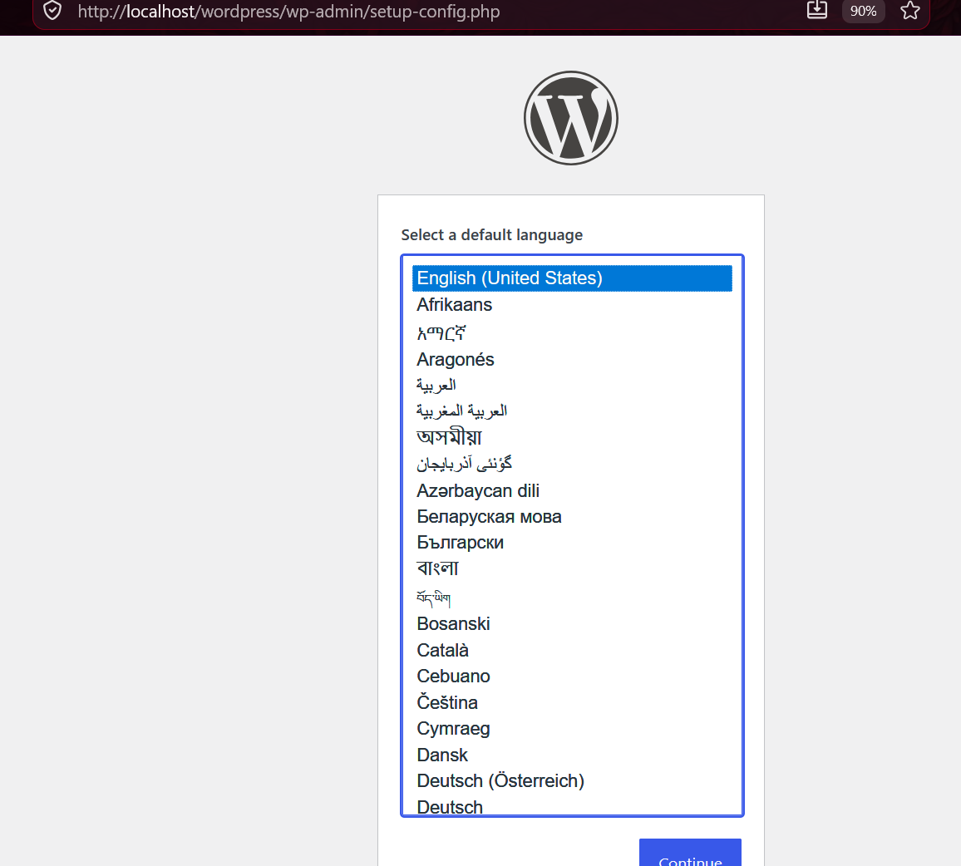

- Enter database name (wp_db), username (root), password (leave blank).
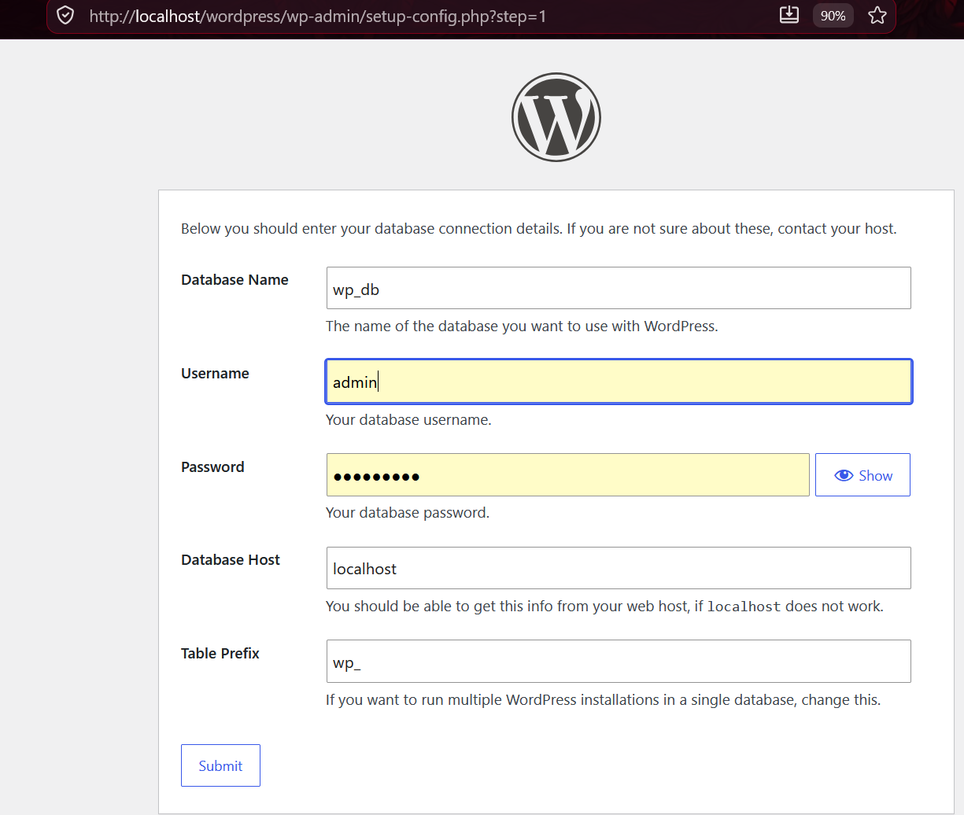

- Click Run the Installation.
- Enter site title, admin username, password, and email.
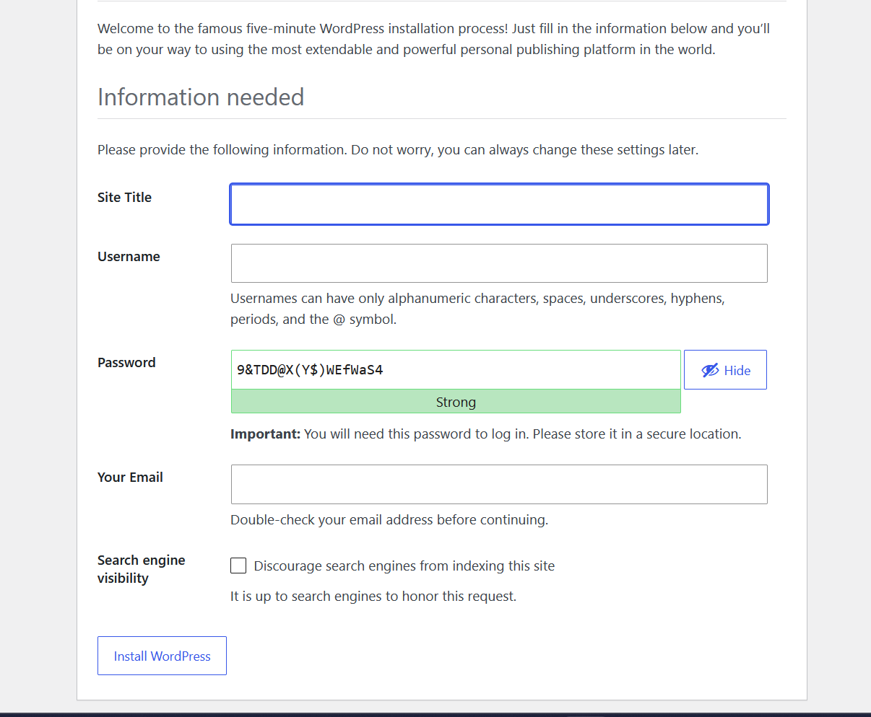

- Click Install WordPress.
- Login at http://localhost/wordpress/wp-admin using the admin details.
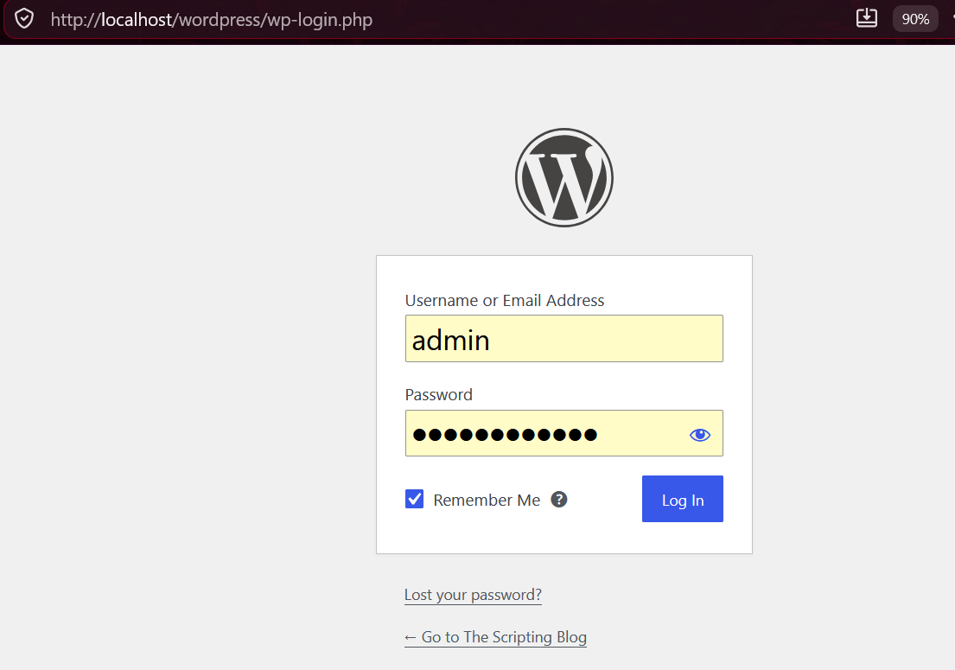

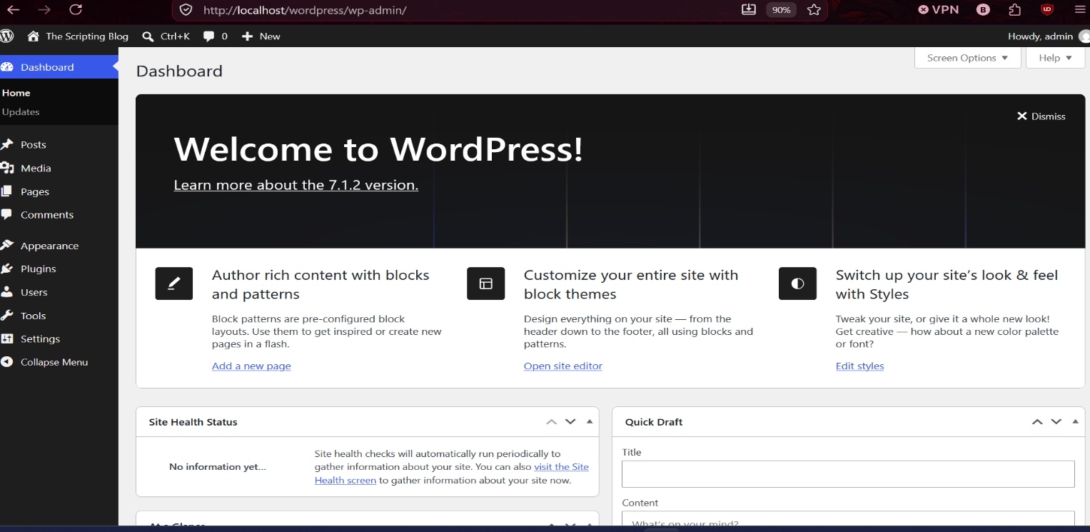

Installing Joomla
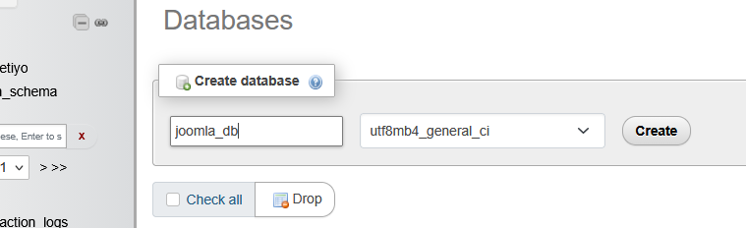
- Go to http://localhost/phpmyadmin and create a new database named joomla_db.

- Download Joomla from joomla.org/download.
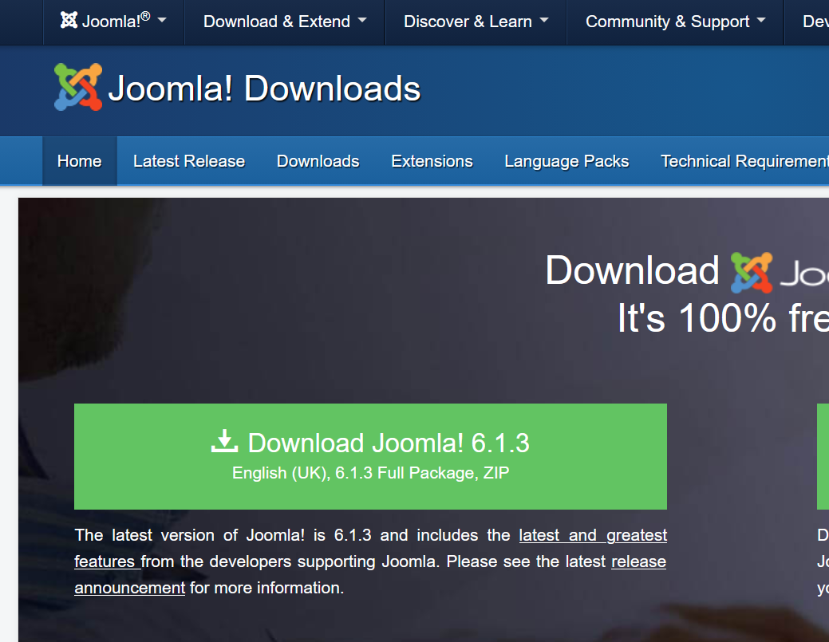

- Extract the Joomla folder into C:\xampp\htdocs\joomla.
- Open http://localhost/joomla in the browser.
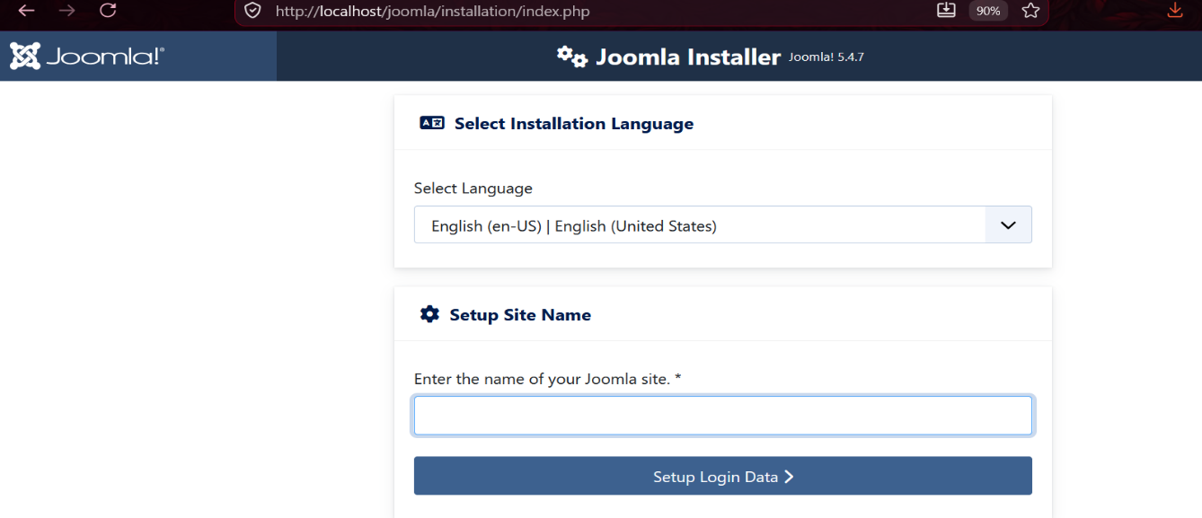

- Enter site name, description, admin username, password, and email.
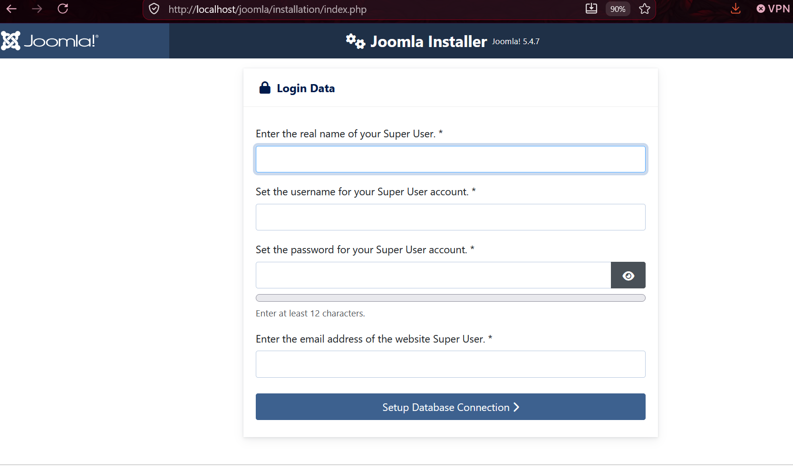

- Click Next.
- Select database type MySQLi, username root, password blank, database name joomla_db.
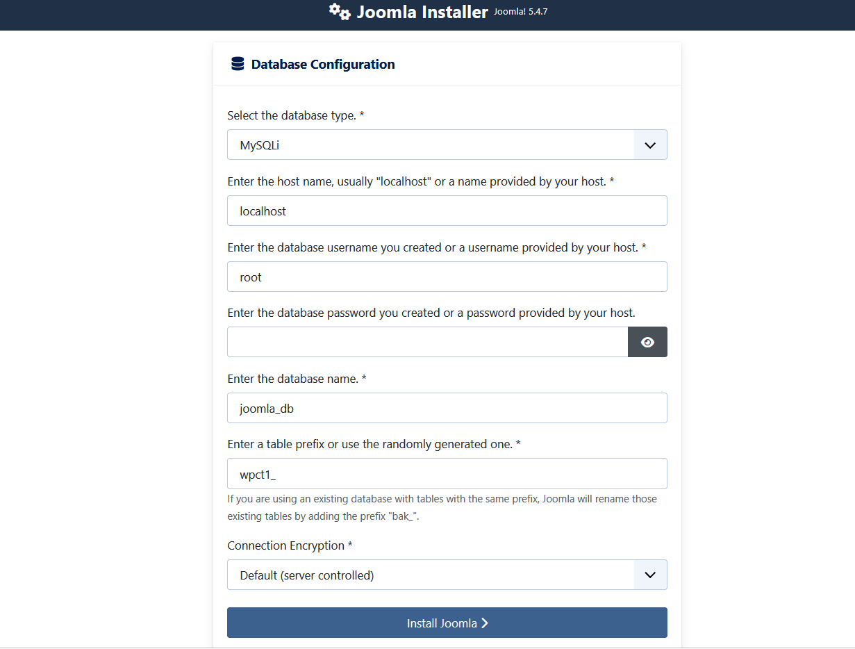

- Login at http://localhost/joomla/administrator using the admin details.
